Table of Contents

1. Introduction 2

2. System Overview 2

3. System Architecture 2

4. Data Design 2

5. Color Theory in System Development 2

5.1. Color Systems 2

5.1.1. Munsell Color System 2

5.1.2. Additive Color System 4

5.1.3. Subtractive Color System 5

5.2. CIE 1931 Color Space 5

5.2.1. Tristimulus Values 5

5.2.2. CIE XYZ color space 5

5.2.3. Color Difference 6

5.2.4. MacAdam Ellipse 6

5.2.5. CIE LAB Color Space 6

6. Component Design 12

6.1. Color Theme Extraction 12

6.1.1. median-cut algorithm 12

6.1.2. octree algorithm 12

6.1.3. kmeans algorithm 12

6.2. Image quality assessments 12

6.2.1. PSNR (Peak Signal-to-Noise Ratio) 12

6.2.2. SSIM (Structural Similarity) 13

6.2.3. VIF (Visual Information Fidelity) 14

6.2.4. GMSD (gradient magnitude similarity deviation) 14

7. Requirements Matrix 14

8. Appendices 14

# Introduction

# System Overview

# System Architecture

# Data Design

# Color Theory in System Development

## Color Systems

### Munsell Color System

#### Introduction

In [colorimetry](https://en.wikipedia.org/wiki/Colorimetry), the Munsell color system is a [color space](https://en.wikipedia.org/wiki/Color_space) that specifies [colors](https://en.wikipedia.org/wiki/Color) based on three color dimensions: [hue](https://en.wikipedia.org/wiki/Hue), value ([lightness](https://en.wikipedia.org/wiki/Lightness_(color))), and [chroma](https://en.wikipedia.org/wiki/Colorfulness" \o "Colorfulness) (color purity).

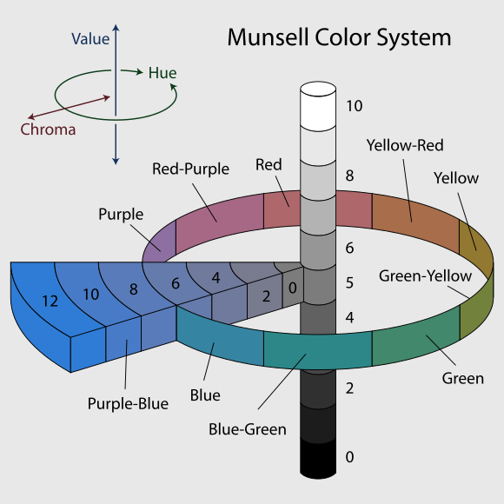

Figure 1 Munsell color system

As Figure 1 shows, in three color dimensions, the horizontal circle stands for hue, and each hue circle is divided into 5 hues (red, yellow, green, blue and purple), along with 5 intermediate hues (e.g., yellow-red).

The second element which represents lightness is value in the vertical dimension, from black (value 0) at the bottom to white at the top (value 10). Neutral grays lie along the vertical axis between black and white.

Chroma, measured radially from the center of each slice (each hue), represents the “purity” of a color, with lower chroma being less pure. Different areas of color space have different chroma ranges. For instance, there are more potential chroma coordinates of light yellow colors than those of light blue colors. The reason why this happens is the nature of our eyes and the physics of color stimuli. The human eye is an organ which reacts light and pressure.  Rod and cone cells in the retina allow conscious light perception and vision including color differentiation and the perception of depth.

The human eye can differentiate between about 10 million colors, but it is impossible to make physics objects in such numbers of colors, and they cannot be reproduced on current computer displays. Vivid solid colors are in range of approximately 8.

#### Visual Analysis -- Color Harmony Types

There are four color harmony types based on Munsell color system, complementary, analogous, monochromatic and diad. These four types focus on the color wheel which is based on hue in Munsell color system.

The figure below (Figure 2) shows 40 standard Munsell hue circle hue divisions.  The color wheel is measured off in one hundred compass points resulting in 100 steps on the hue circle.

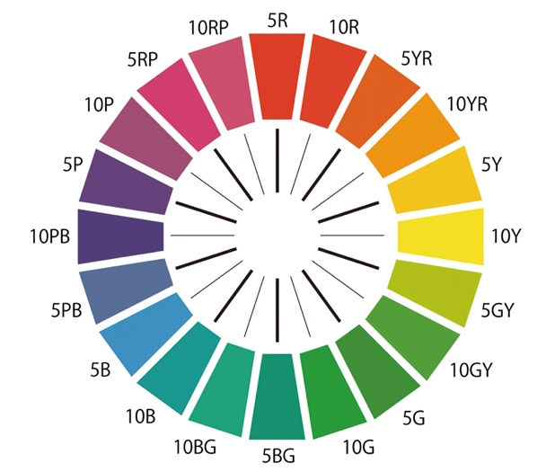

Figure 2 color wheel in Munsell color system

##### complementary color harmony

In the complementary color harmony type, we can say the two colors in the opposite position in the color wheel are harmonious. For instance, in Figure 2, the combination of 5R (red) and 5BG (bluegreen) is harmonious because 5R and 5GB are complementary colors.

##### analogous color harmony

Three colors adjacent to each other are defined as analogous color harmony. To be more specific, 5R, 10R and 5YR in the color wheel can be used to create a harmonious color theme.

##### monochromatic color harmony

Monochromatic color harmony only uses one hue with various tints, tones and also shades. We define

1. tint: hue color adding white color;
2. tone: hue color mixed with gray;
3. shade: hue color with black color

Based on the definition, we can know that hue-value combinations are regarded as a harmonious monochromatic color harmony.

##### diad color harmony

In the diad color harmony, we can choose two colors apart on the color wheel randomly, like 5Y and 5YR, which is the easiest way to apply.

### Additive Color System

#### RGB Color Space

In the additive color system, all the colors are the mixtures of some light colors. Red, green and blue are the most common primary colors used in the additive color system, which is known as RGB color model. RGB is a method of presenting colours electronically by projecting light rays unto screens, such as TV or computer screens. Each light ray has its unique wavelength that creates a specific colour.

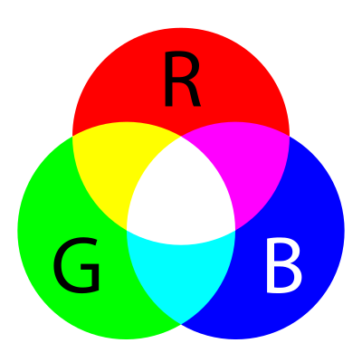

Figure 3 RGB color model

As Figure 3 shows, any two of standard additive primary colors (red, green and blue) combine into secondary colors, which are yellow, cyan and magenta.

Additive color is a result of the way the eye detects color and is not a property of light. There is a vast difference between a pure spectral yellow light, with a wavelength of approximately 580 nm, and a mixture of red and green light. However, both stimulate our eyes in a similar manner, so we do not detect that difference, and both are yellow light to the human eye.

#### HSV Color Space and HSL Color Space

HSV and HSL color spaces are two alternations of the RGB color model, which are designed for human vision.

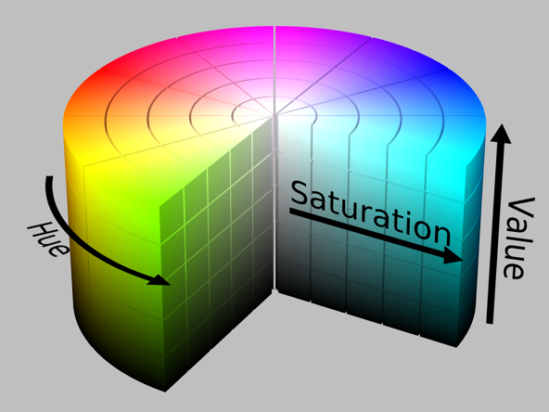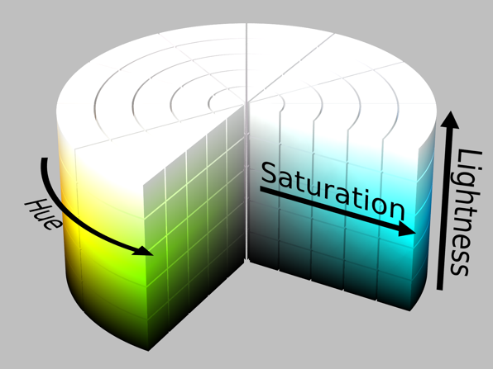

Figure HSV color space. Figure HSL color space

HSV means hue, saturation and value, and HSL means hue, saturation and lightness. Although these two color spaces are very similar, the definition of saturation is different in each color space. As mentioned before, the primary colors (red, yellow, blue) and the secondary colors (green, cyan, magenta) are also called pure colors in the additive color system, which means they are on the edge of the hue circle with full saturation. In HSV, the value is 1 for pure colors, but in HSL they have 0.5 lightness.

In both color spaces, if we mix pure colors with black color (called shades), the saturation won’t change. Additionally, saturation leaves unchanged if adding only white into pure colors in HSL color space, and only tones which are mixtures of black and white will change saturation (less than 1). For HSV, tinting pure colors with white reduces saturation.

### Subtractive Color System

#### Introduction

The basis of subtractive color system is light, specifically white light. Any colored object like paintings subtracts wavelengths from the light, giving it colors, so the color that an object displays depends on which parts of the visible spectrum are not absorbed and reflect to our eyes.

## CIE 1931 Color Space

### Tristimulus Values

CIE 1931 color space is the first one that bridges the gap between the electronic wavelengths and the perceived colors in human vision.

There are 3 kinds of cone cells in human eyes that sense light, having peaks of spectral sensitivity in short, middle and long wavelengths, which underlies human color perception in conditions of medium and high brightness. The concept “tristimulus values” is introduced to correspond the level of stimulus of these 3 kinds of cone cells. We can weigh the total light spectrum into 3 parameters in tristimulus values (denoted s, m, l) which is denominated as LMS color space, and these 3 parameters can also be associated with color spaces to generate 3 primary colors in additive color space.

### CIE XYZ color space

#### Introduction

In CIE XYZ color space, all colors that human with average eyesight can sense are included, so this is a device-invariant color space and always regarded as a reference color space.

LMS tristimulus values for pure spectral colors (like RGB color spaces) would imply negative values for at least one of the three primaries because the chromaticity would be outside the color triangle defined by the primary colors.

In order to avoid these negative values and to have one component that describes the perceived brightness, "imaginary" primary colors and corresponding colors matching functions were formulated.

CIE 1931 color space defines the resulting tristimulus values, in which they are denoted by "X" (mix of cone response curves chosen to be nonnegative),"Y” (luminance) and "Z” (blue stimulation or the S cone response). In XYZ space, all combinations of non-negative coordinates are meaningful, which correspond to imaginary colors outside the space of possible LMS coordinates, so we can say that CIE XYZ color space answer the question: what color it is?

#### Definition

The tristimulus values for a color with a spectral radiance  are given in terms of the standard observer by:

where {\displaystyle \lambda }is the wavelength of the equivalent monochromatic light, and the standard limits of the integral are {\displaystyle \lambda \in [380,780]}.

The values of *X*, *Y*, and *Z* are bounded if the radiance spectrum is bounded.

### Color Difference

The difference or distance between 2 colors is a metric of interest in color science.

The standard means of determining distances is Euclidean distance: If these squared color distances are summed, such a metric effectively becomes the variance of the color distances.

There are many attempts to weight the RGB values to better fit human perception, where components are commonly weighted (red 30%,blue 40%, green 30%)，however these are demonstratively worse at color determinations and are properly the contributions to the brightness of these colors, rather than to the degree to which human vision has less tolerance for these colors.

The closer approximation would be more properly coefficient of 2,4,3

### MacAdam Ellipse

It confirmed color difference could be measured with a metric in a chromaticity space, so we can say that MacAdam Ellipse answers the question: How different are these 2 colors?

link: <https://en.wikipedia.org/wiki/MacAdam_ellipse>

### CIE LAB Color Space

#### Introduction

Based on MacAdam Ellipse, CIE LAB (also known as CIE L*a*b*) color space is the most notable color space which is aimed to reduce the distortions in CIE XYZ color space.

The nonlinear relations for *L\**, *a\**, and *b\** are intended to mimic the nonlinear response of the eye. Furthermore, uniform changes of components in the *L*a*b\** color space aim to match uniform changes in perceived color, so the relative perceptual differences between any two colors in *L*a*b\** can be approximately treated as 2 points in a three-dimensional space (with three components: *L\**, *a\**, *b\**) by using Euclidean distance to measure them. CIE LAB color space is less distorted, but not free of distortion.

#### Definition

In CIE LAB color space, L* stands for the lightness and a* and b* represent the green–red and blue–yellow color components respectively.

We can convert XYZ color space to CIE LAB color space with 3 formulas shown below:

where

*X*n, *Y*n and *Z*n are the CIE XYZ tristimulus values of the reference white point (the subscript n suggests "normalized").

#### Visual Analysis – Color Harmony

Technically the color wheel shown below in Adobe Illustrator has most similarities with LAB color wheel but more visually.

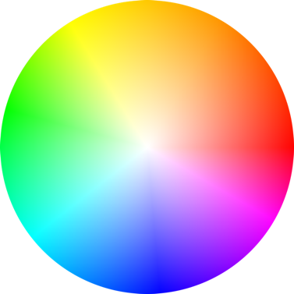

Figure

There are 23 color harmonies built in Adobe Illustrator, and the majority of color harmony types are same as those in Munsell color system. I will only show those different ones.

##### complementary color harmony

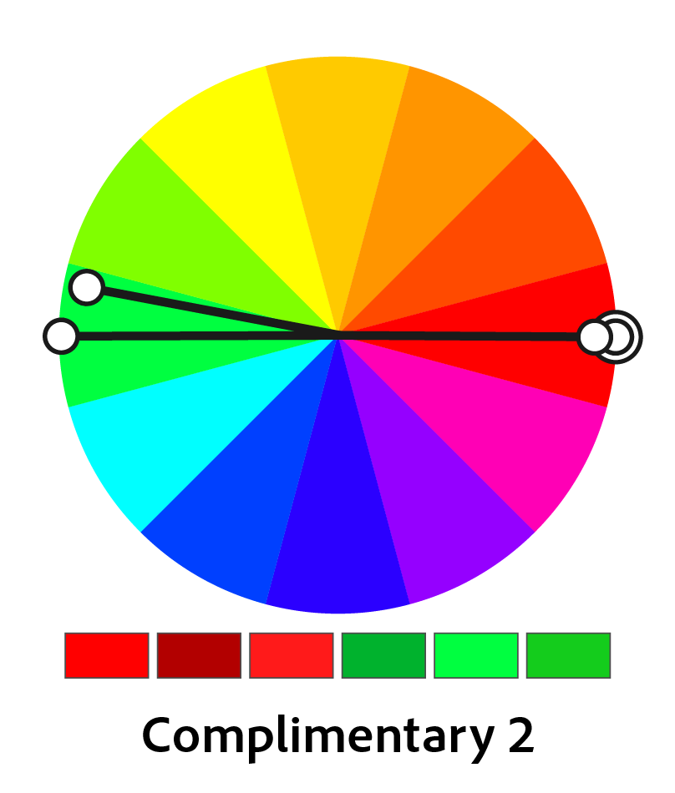

Figure

In addition to the original complementary color harmony, we can add one brightness and one saturation variant on the original color, and also the same to the complementary color, so we can have a harmonious color scheme with 6 colors.

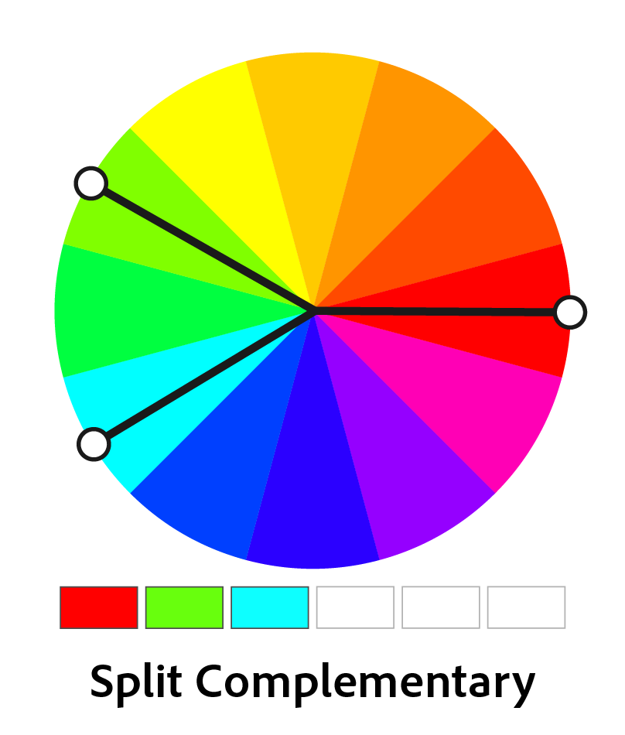

Figure Split color harmony

For the split complementary color rule, we split off one of original complementary colors by 30 degrees clockwise and counter-clockwise to produce 3 colors.

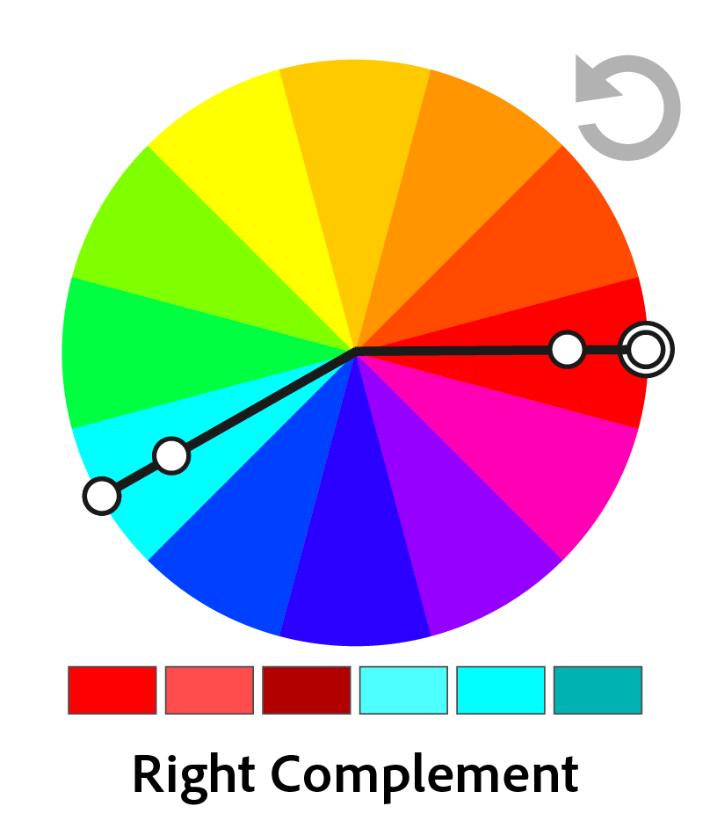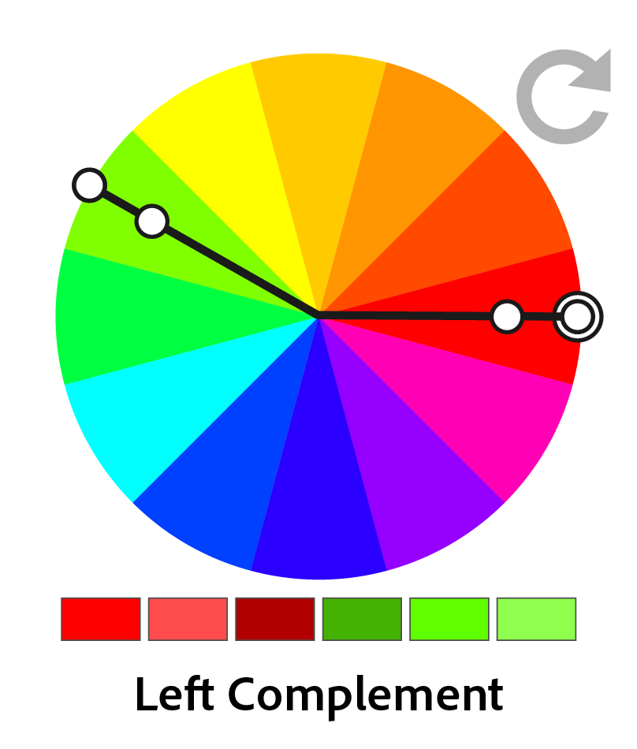

Figure Left Complementary Color Harmony Figure Right Complementary Color Harmony

Left and right color harmonies are two variations bend complementary color rules, with counter-clockwise and clockwise separately. we then add brightness, saturation shifting to the color schemes.

##### Analogous Color Harmony

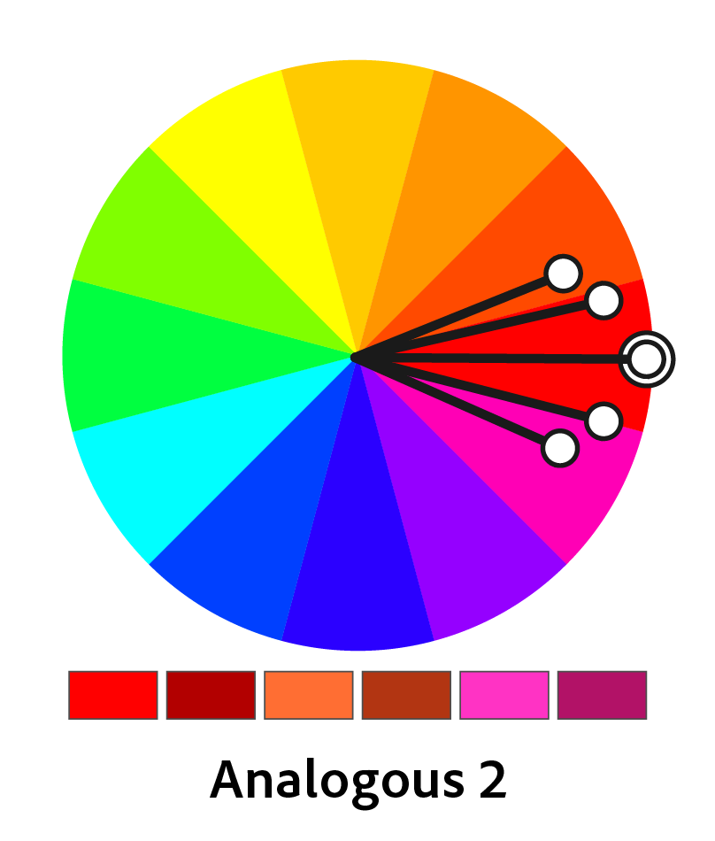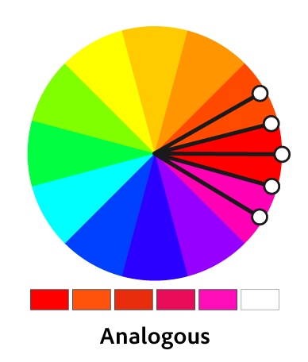

The analogous color harmony rule goes to shift the original color by 15 or 30 degrees with deeper saturation and brightness.

##### Triadic Color Harmony

In the color wheel, we split off the original color by 120 degrees, and then those 3 colors are called a triadic color harmony.

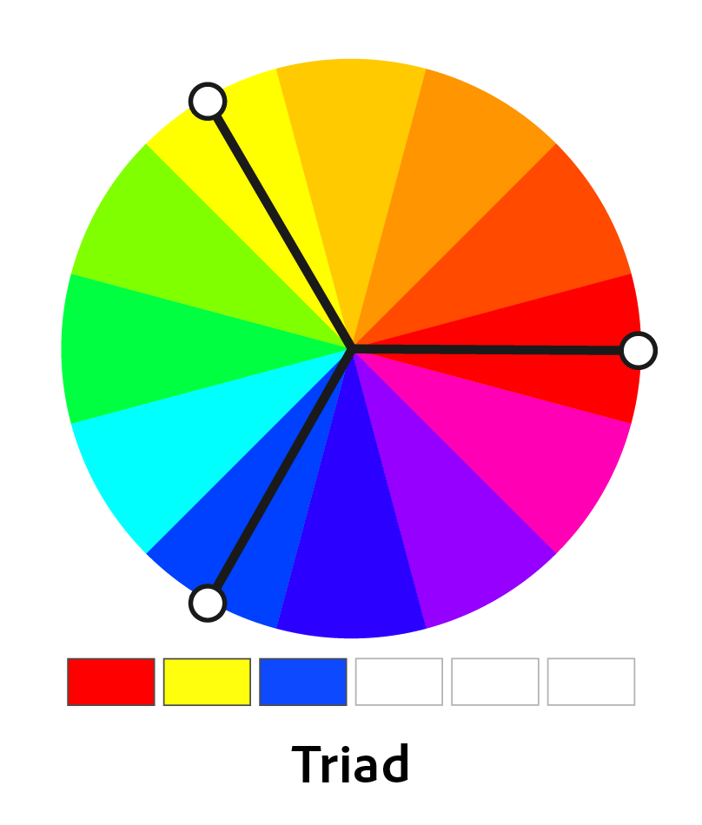

Figure Triadic Color Harmony

Moreover, we can also add saturation and brightness variants into this harmony to create more color schemes with more colors.

##### Tetrads Color Harmony

Tetrads, which means diamond shape, show the color harmony with 2 pairs of complementary colors. The original color generates 3 additional colors hue-rotated by 90 degrees and with a 5% decrease in saturation.

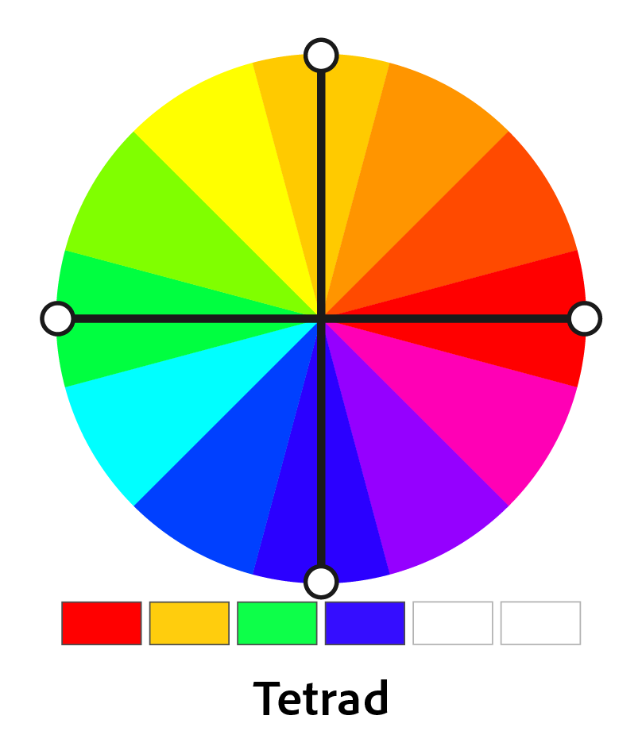

Figure

We can also combine complementary color harmony with this one. For example, one pair of complementary colors can be rotated left or right by 30 or 15 degrees with modulation of the brightness or saturation.

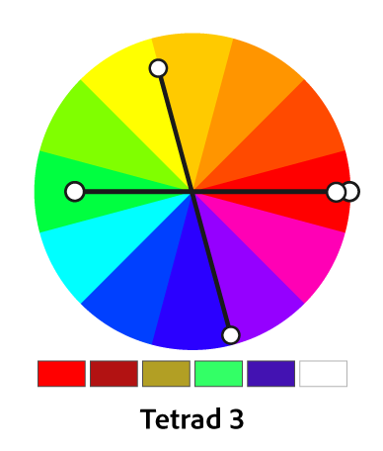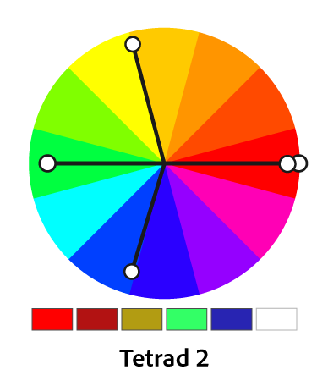

Figure Figure

##### Compounds Color Harmony

This rule consists of analogous and complementaries with clockwise and counter-clockwise variations of each other.

##### High Contrast Color Harmony

High contrast color harmony is based on triad color harmony, but with additional other harmony methods. There are 4 kinds of high contrast color harmony in it.

The first one is a combination of monochromatic variation and left-analogous variation of the original color, with a left complement with brightness or saturation variation, so we can have a 5-color scheme for this rule.

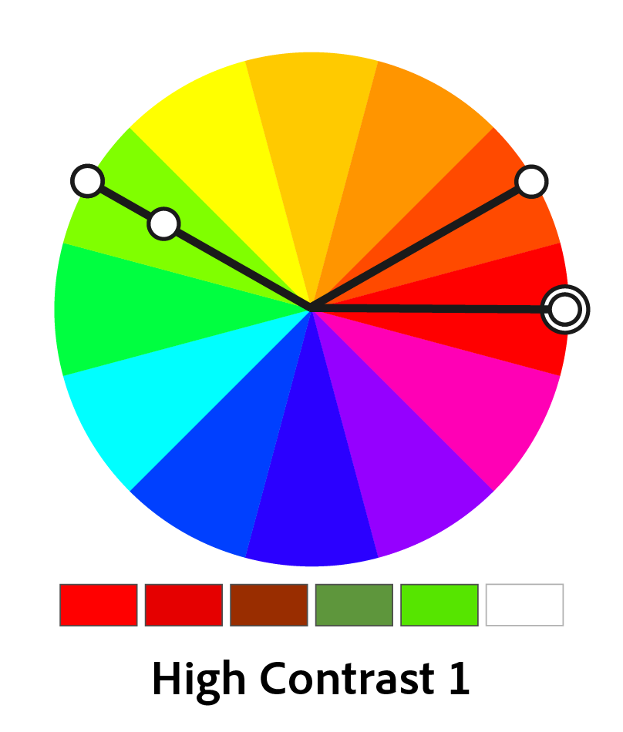

Figure

The only rule goes to a 6-color scheme is the second one. it consists of the basic triad color harmony and the brightness or saturation modulation.

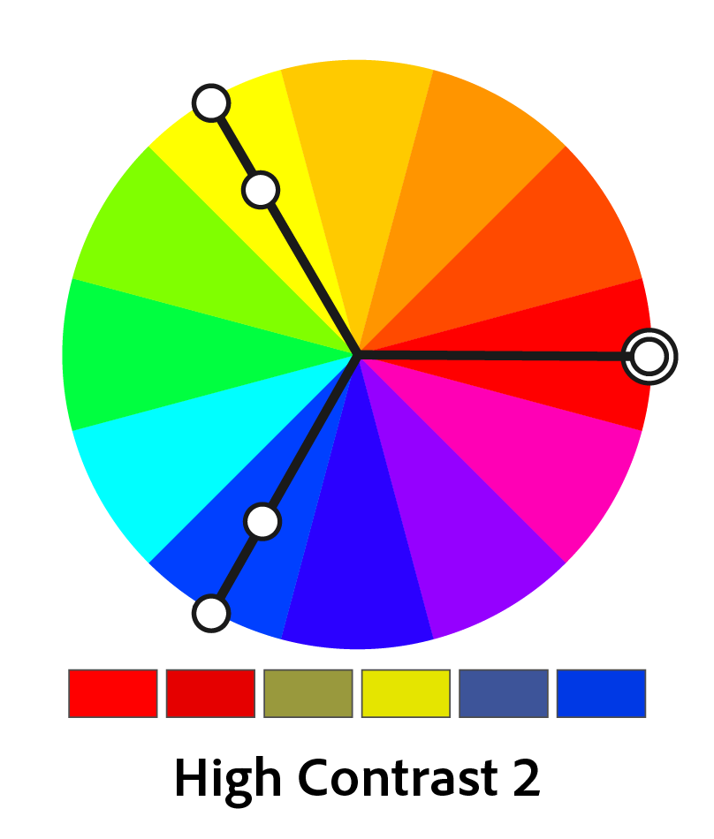

Figure

We can create an analogous variant, along with brightness modulation of this color, with 90-degree counter-clockwise hue variation.

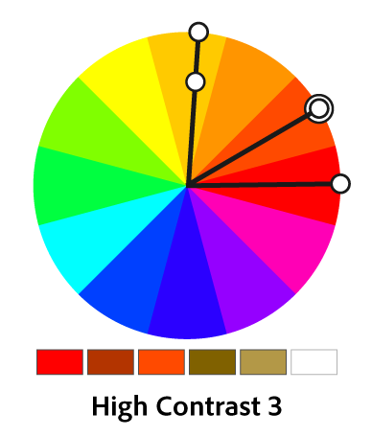

Figure

The last one is similar to the first one. We can change the original color and the rotation direction, producing one more brightness variant based on the new color.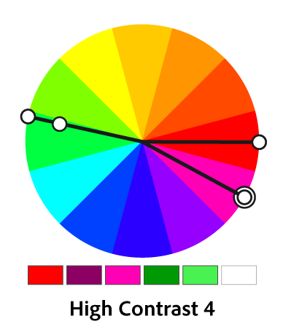

Figure

# Component Design

## Color Theme Extraction

### median-cut algorithm

#### Introduction

There are two main steps for implementing median-cut algorithm:

1. Create a “cube” of the colors in the pixels of an image by using each color component (R, G, and B) as an axis (e.g. x, y, z):
   * Calculate the range of each color component (R, G, and B)
   * For the component with the largest range, C, calculate the median value, M
   * Split the “cube” of colors:
     + one cube containing the RGB values of all pixels where the C component is greater than M
     + one cube containing the RGB values of all pixels where the C component is less than M
   * If the number of cubes is equal to our chosen number of desired colors, exit the loop
   * For each color cube, calculate the range of each component, choose the cube which contains the largest range, and repeat
2. For each cube, apply some function (mean, median, mode, etc) to the value of each component, and combine into a new RGB value.

### octree algorithm

link: <https://www.hindawi.com/journals/cin/2016/5302957/>

### kmeans algorithm

link: <https://lmcaraig.com/color-quantization-using-k-means/#selectionwithkmeans>

## Image quality assessments

### PSNR (Peak Signal-to-Noise Ratio)

#### Introduction

PSNR is an engineering term for measuring ratio between the maximum possible power of a signal and the power of corrupting noise that affects the fidelity of its representation in terms of the logarithmic decibel scale.

#### Definition

PSNR is defined via mean square error (MSE). Given a noise-free monochrome image and its noisy approximation , is defined as:

The (in dB) is defined as:

In the equation above, represents the maximum possible value of the image, and the value of is 255 when there are 8 bits in per pixel.

#### Application

For color images, for instance, as for RGB color images (size ), MSE is defined as:

Alternately, if images are in different color spaces, PSNR shows each channel of that color space. Based on this, we can define the PSNR in LAB color space.

### SSIM (Structural Similarity)

#### Introduction

SSIM is a full reference metric, which means that this measurement is based on an initial uncompressed or distortion-free images as reference.

As it shows above, PSNR just focuses on the absolute errors between images, so SSIM is designed to improve this traditional method. SSIM is perception-based model that considers image degradation as perceived change in structural information.

While still considering luminance and contrast masking terms, the structural information is aimed to find the inter-dependencies among pixels especially they are spatially close.

#### Definition

SSIM consists of 3 components L for luminance, C for contrast, S for structural information.

In order to simplify the formula, we set , so the SSIM formula can be reduced to the form shown below when measuring between 2 windows x and y of size NxN is:

SSIM should satisfy the symmetry:

#### Application

As for image quality evaluation, SSIM formula is always applied only for brightness of an image, although it can be used for other color spaces: color values (e.g. RGB) or chromatic values (e.g. YCbCr). Typically, it is calculated on window sizes of 8x8.

### VIF (Visual Information Fidelity)

#### Introduction

VIF index introduces natural scene statistical model in conjunction with a distortion(channel) model to quantify the information shared between the reference and test images, so this measurement does not rely on any HVS (Human Visual System) or viewing geometry parameter. It treats HVS as a communication channel and predicts the subjective image quality by computing how much the information within the perceived reference image is preserved in the distorted one.

#### Definition

In VIF, an approach called “information-theoretic setting” is included. the reference image and the test image are in 2 different processes through the measurement. The reference image is regarded as natural image source that goes through HSV channel before being processed to the brain. The information comes from the reference image is quantized as being mutual information between input and output of HSV channel. This kind of information is that the brain could ideally extract from the reference image. The same measurement is also applied for the test image. There is a distortion channel that distorts the output of the natural image source before it comes to HSV channel, thereby we can get the information that brain can extract from the test image. Finally, we can combine those 2 results from each phase to get the VIF evaluation. The figure below shows this whole measure process.

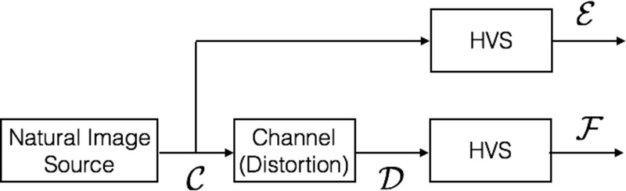

figure

Source Model

Distortion Model

HVS Model

link: <https://en.wikipedia.org/wiki/Visual_Information_Fidelity#cite_note-4>

### GMSD (gradient magnitude similarity deviation)

#### Introduction

The image gradients are sensitive to image distortions, while different local structures in a distorted image suffer different degrees of degradations. This motivates the exploration of the use of global variation of gradient based local quality map for overall image quality prediction.

The pixel-wise gradient magnitude similarity (GMS) between the reference and distorted images combined with a novel pooling strategy—the standard deviation of the GMS map—can predict accurately perceptual image quality.

#### Definition

link: <https://ieeexplore.ieee.org/stamp/stamp.jsp?tp=&arnumber=6678238>

# Requirements Matrix

# Appendices